

King Saud University

College of Computer and Information Sciences

Department of Information Systems

IS 351 Project Management

Instructor: Mohammed Alnajim

O-go application

|  |
| --- |
| Students |
| Nawaf Albabtain | 441101451 |
| Abdulrhman Alaskar | 441102386 |
| Abdullah Alwarqan | 441102748 |
| Hosam almotawa | 439100445 |

Contents

Introduction 3

Objectives 3

Description 3

Gantt Chart 4

Task links 4

Constrains 5

Resource sheet 7

Calendars 7

Resource task assignment 9

Statistics 10

Conclusion 13

# **Introduction**

The evolution of technology will play an important role in the 2030 vision of Saudi Arabia, In the interim, there are various delivery applications, but our major goal in this project is to create an application that will allow customers to order from numerous restaurants from anywhere and then drive to them to pick up their meal without the need for a delivery guy.

# **Objectives**

* Avoid eating at crowded restaurants
* Keep up with 2030 vision
* Less waiting in restaurants

# **Description**

To organize our project, build our Gantt Chart, and assign our resources to the tasks, we used Microsoft Project. Our project is divided into six phases, which are as follows:

* Initiation phase

It is the stage that will initiate our project and identify the users for the application then get approval.

* Planning and analysis phase

This stage includes collecting requirements, characterize use cases, and define functional requirements.

* Designing phase

In this stage we will design the transaction history, balance status and digital receipts.

* Development phase

In this stage we will obtain our staff and appoint them to their tasks which are application security and funds transfer development.

* Testing phase

In this stage we will begin testing our program by using user experience test and we will do a security test, then we will identify the errors and fix the app.

* Closing phase

In this stage our project will be completed and ready to launch.

# Gantt Chart

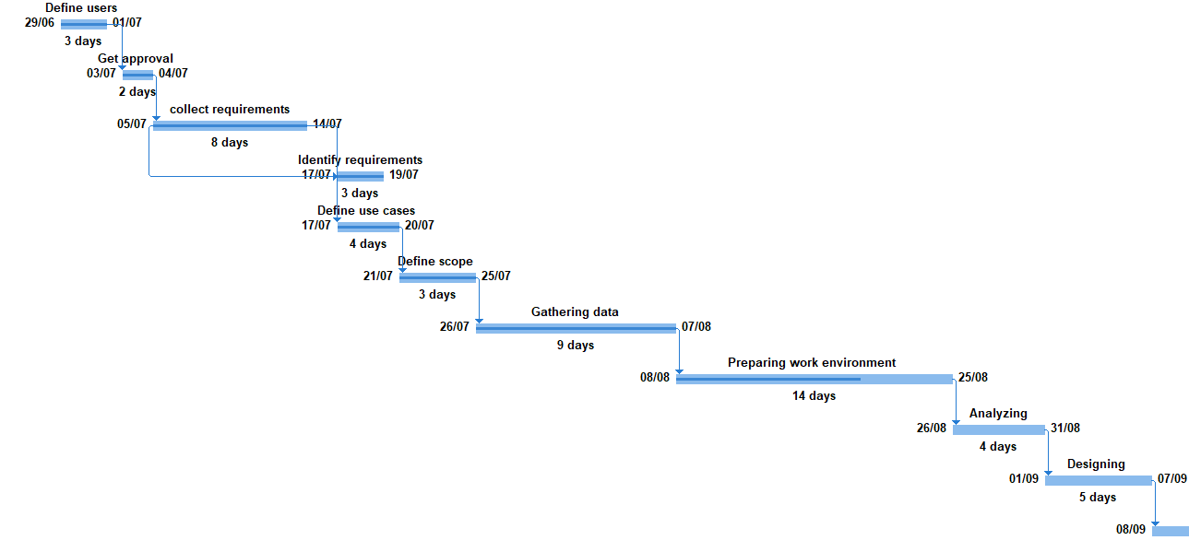

## 

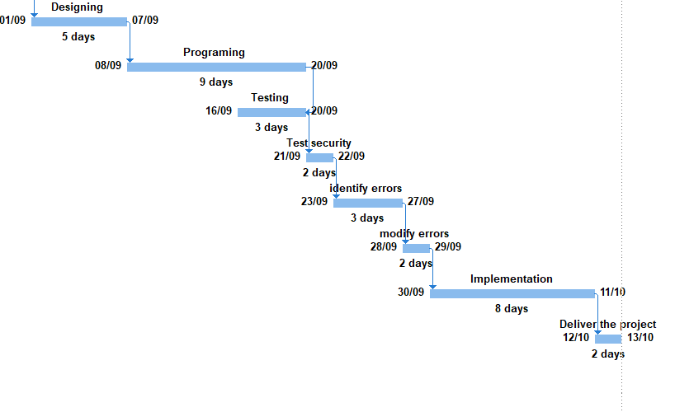

## Task links

* From collect requirements to identify requirements is (SS)
* From programing to testing is (FF)
* From identify errors to modify errors is (FS)

## 

## Constrains

Finish No Earlier Than

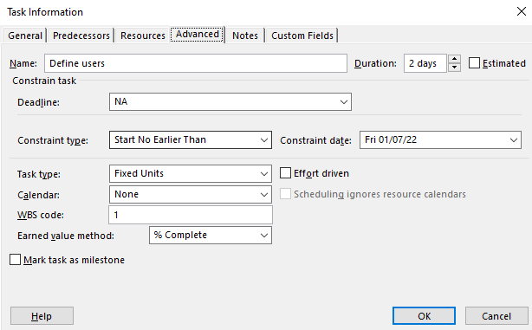

As soon as possible:

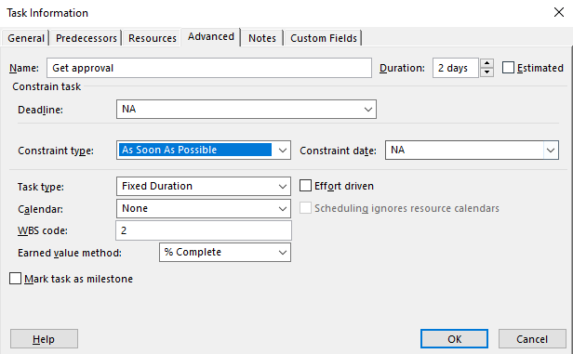

Start no earlier than:

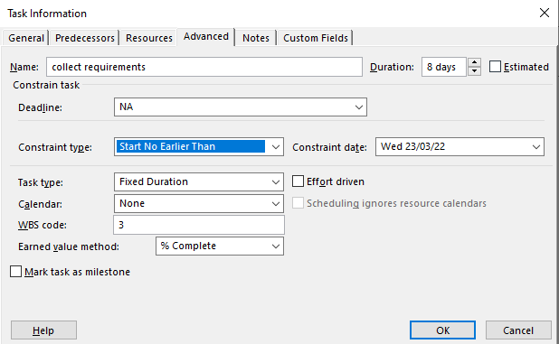

# 

# Resource sheet

As shown, we used two types of resources, Work & Material.

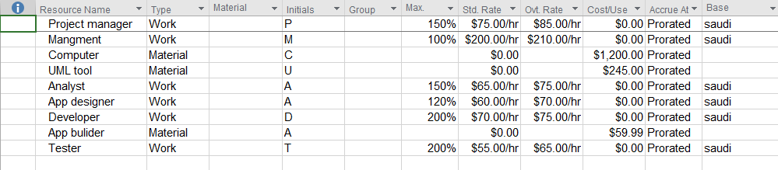

# Calendars

We created two calendars for two of our resources:

Developer 's calendar

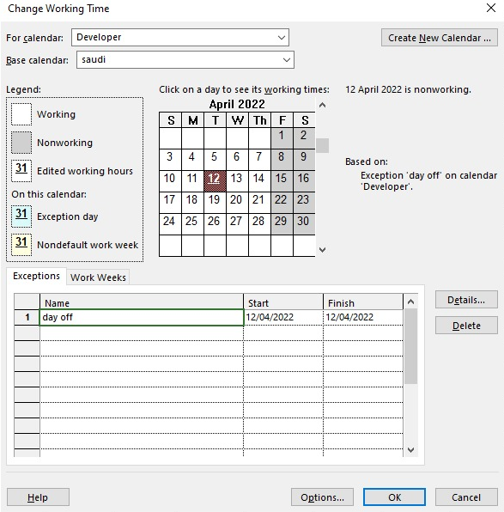

Analyst 's calendar

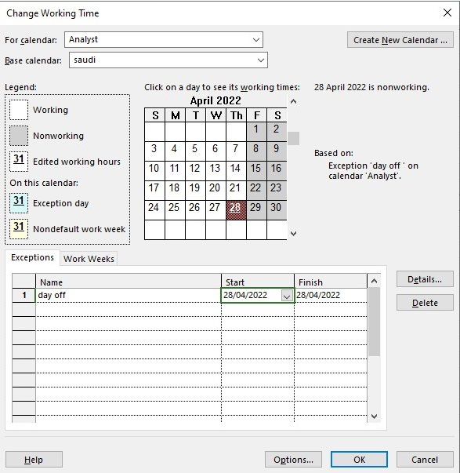

# Resource task assignment

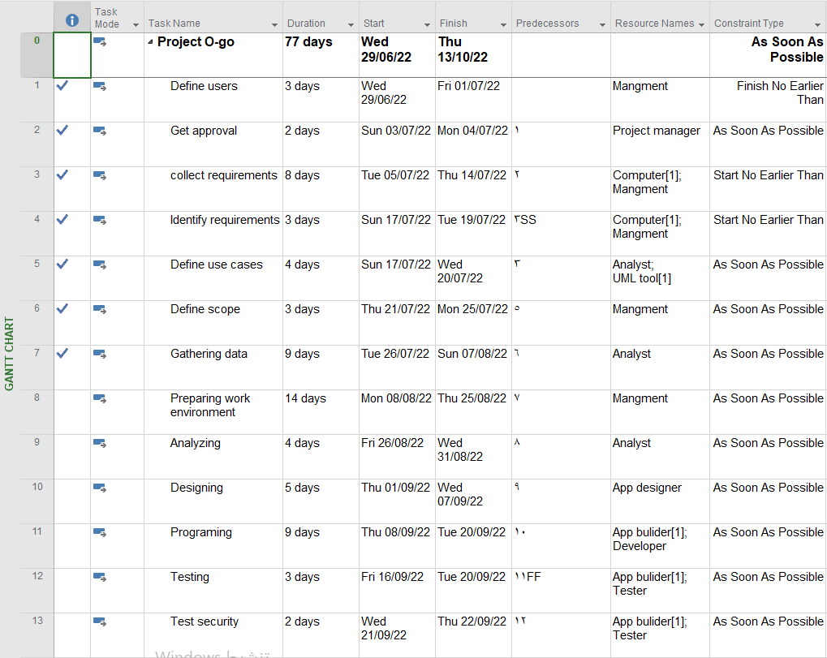 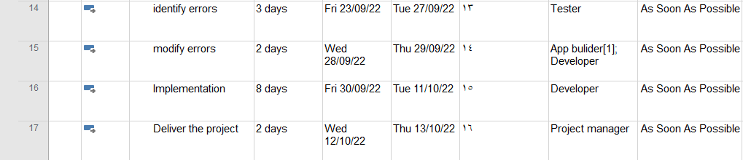

# 

# Statistics

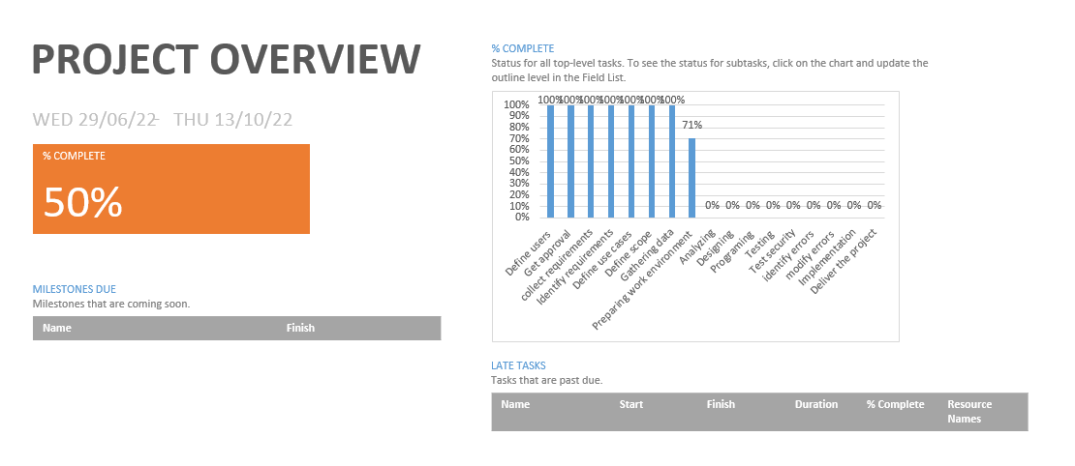

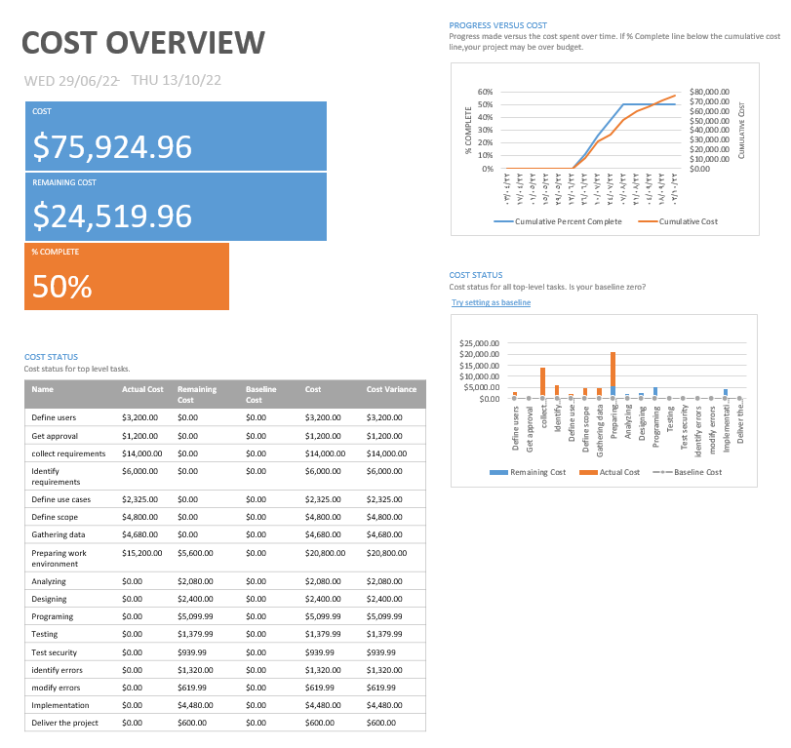

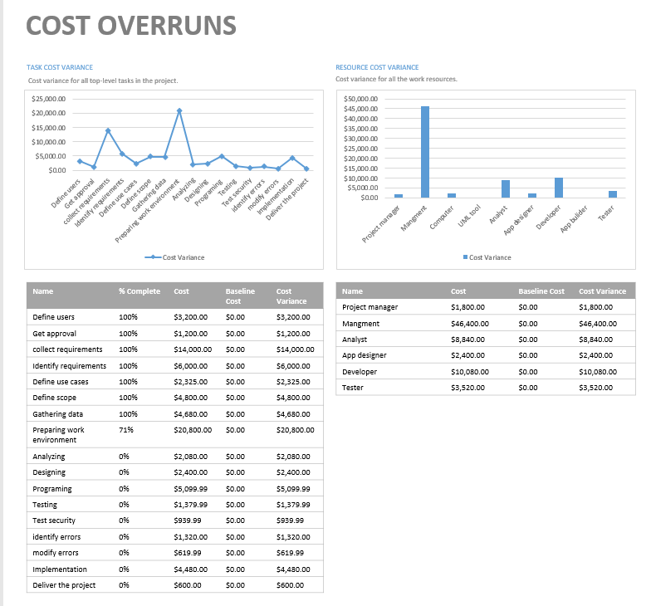

# 

# Conclusion

In the end of our project, we learnt how hugely important it is to plan and manage your project before you begin it, and we were introduced to Microsoft Project, a powerful tool for doing so. This application made it much easier to organize our project because it generates an automatically calculated schedule and reports, as well as allowing you to assign resources to their tasks and build customized calendars for them. Finally, we can state that we are familiar with all of Microsoft Project's main features.